Lessons
1. Course introduction
2. Names for the Bible
3. Course Outline
4. How we got the Bible (part 1)
5. Course Goal

Chapter 1: The Book Called “The Bible”
6. How the Bible is Organized – Key Concepts
7. Open your Bible...
8. The Old Testament
9. The New Testament
10. The Canon of Scripture – How we got the Bible (part 2)
11. Ways to use your Bible
12. Steps for studying the Bible
13. Chapters & Verses
14. The best way to read and study the Bible
15. Meditating on Scripture

Chapter 2: Key Concepts
16. Divine Authorship of the Bible
17. How God Communicates With people
18. Powerful Acts of God
19. God’s Messengers
20. Why God gave us the Bible
21. Inspiration of Scripture
22. Bible Writers
23. The Word of God
24. Authority of Scripture

Chapter 3: Principles for Interpreting the Bible
25. Follow intended meaning
26. Understand the difference between LITERAL and FIGURATIVE text.
27. Read and understand every verse of the Bible in its CONTEXT
28. Interpret Scripture in harmony with itself
29. Interpret Scripture Christologically

Chapter 4: Tools for Understanding the Bible
30. Tools for Studying the Bible
31. Historical Grammatical Tools
32. Historical Background Tool
33. The Tool of Culture
34. Theological Tools
35. The Law of God: “Curb”
36. The Law of God: “Mirror”
37. The Law of God: “Guide”
38. Summary: Three Functions of the Law
39. Law and Gospel
40. Justification and Grace
41. Rightly Dividing the Word of Truth

Chapter 5: Becoming Familiar with the Old and New Testaments
42. Important Old Testament Concepts
43. Important New Testament Concepts
44. Understanding Bible History
45. Understanding Prophecy
46. Understanding Poetry in the Bible
47. Understanding the Gospels
48. Understanding the Epistles
Final Exam
Appendix
How we got the Bible
The Canon of Scripture
Getting the Bible in Our Own Language
Evidence for the Reliability of Scripture

Lesson 1 – Course Introduction

How to Study and Understand the Bible is an online DeafPah! course that helps prepare church members to serve in their congregation’s ministry. The instructor for this course is Rev. David Bush.

You may download the video lessons and this study guide for free from deafjesus.org.

The videos were originally prepared as VHS videotapes for the Deaf Institute of Theology.

The textbook that originally was the basis for this course is no longer in print. However, we have included in this student guide reference materials cited in the videos lessons.

While you watch the videos, take notes, especially when the teacher describes a list of topics. At the end of each video lesson, reinforce what you have learned by answering the questions in this student guide.

If you are studying this course with a mentor, share your answers with your mentor.

Now please watch Part 1 video.

QUESTIONS
1. What are some of your favorite Bible stories? ...and why?

2. What are your favorite Bible verses? ...and why?

Lesson 2 – Names for the Bible
Watch Part 2 video.

1. The word BIBLE comes from a Greek word that means ________________

2. Why do we Sign “Bible” as “Jesus-Book”?

3. What are some other names that mean the Bible?

Lesson 3 – Course Outline
Watch Part 3 video.

A friend tells you that she wants to start reading the Bible to learn about God. What advice would you give to your friend to help her to get the most benefit from reading the Bible?

Lesson 4 – How we got the Bible (part 1)
Watch Part 4 video.

Also please read the appendix at the end of this study guide. There you find important information about how we got the Bible.

1. The chief original languages of the Bible are:

(a)

(b)

Read Matthew 24:35
2. What does God promise about His Word?

Read Revelation 22:18–19
3. God commands us NOT to do two things to the Bible.

v. 18

v. 19

3. What English version (translation) of the Bible do you like best? (Examples: KJV, NKJV, NIV, NIRV, etc.) Do you have a favorite Bible version? Which one? Why?

Lesson 5 – Course Goal
Watch Part 5 video.

1. Do you have any books that you use to help you study the Bible and understand it better? (Examples: a Bible dictionary, a concordance, commentaries, a Bible with maps and footnotes that explain the verses.)

If your answer is yes, what books do you have?

Which of those books help you the most?

2. Are there internet websites that help you understand the Bible better?

If your answer is yes, what Bible websites do you often use?

We recommend these Bible websites:
biblegateway.com biblehub.com blueletterbible.org

Lesson 6 – HOW THE BIBLE IS ORGANIZED: Key Concepts
Watch Part 6 video.

Read 2 Timothy 3:16
This lesson teaches two key concepts for understanding the Bible:

(1)

(2)

Lesson 7 – Open your Bible...
Watch Part 7 video.

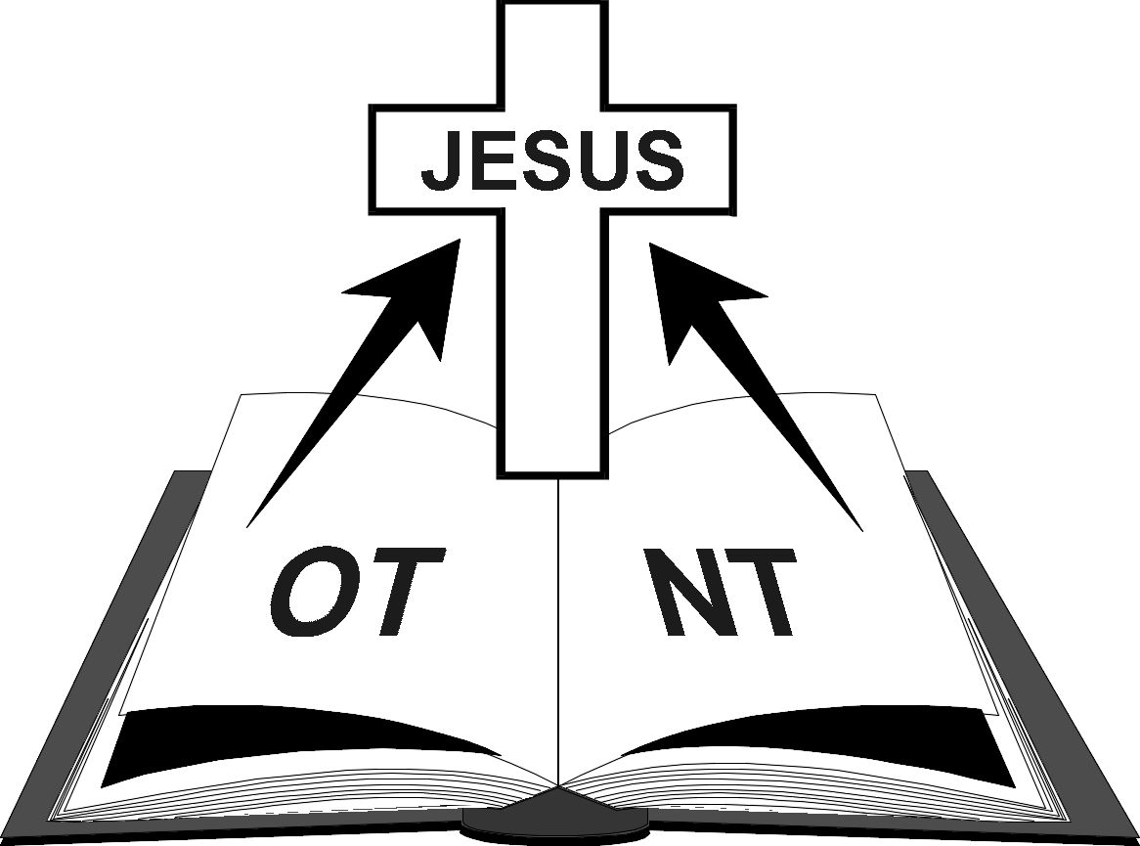  Old Testament New Testament  39 Books + 27 Books  66 Books  1 Bible | 1. “The Bible is like a library.”  Explain what that means.  2. “Reading the Bible is like eating at a restaurant.” Explain what that means.

Old Testament | New Testament
History Books  Genesis  Exodus  Leviticus  Numbers  Deuteronomy  Joshua  Judges  Ruth  1 Samuel  2 Samuel  1 Kings  2 Kings  1 Chronicles  2 Chronicles  Ezra  Nehemiah  Esther  Poetry Books  Job  Psalms  Proverbs  Ecclesiastes  Song of Solomon  Prophecy Books  Isaiah  Jeremiah  Lamentations  Ezekiel  Daniel  Hosea  Joel  Amos  Obadiah  Jonah  Micah  Nahum  Habakkuk  Zephaniah  Haggai  Zechariah  Malachi | }  History Books  Matthew  Mark  Gospels  Luke  John  Acts of the Apostles  Epistles  Romans  1 Corinthians  2 Corinthians  Galatians  Ephesians  Philippians  Colossians  1Thessalonians  2 Thessalonians  1 Timothy  2 Timothy  Titus  Philemon  Hebrews  James  1 Peter  2 Peter  1 John  2 John  3 John  Jude  Prophecy/Apocalypse  Revelation

Lesson 8 – The Old Testament
Watch Part 8 video.

1. What does the word TESTAMENT mean?

2. What are the four main parts of the Old Testament?

(a)

(b)

(c)

(d)

3. The Old Testament has many promises. What is the most important promise in the Old Testament?

Lesson 9 – The New Testament
Watch Part 9 video.

1. The New Testament reports that God kept (fulfilled) the most important promise that He made in the Old Testament. What did God do?

2. What are the four main parts of the New Testament?

(a)

(b)

(c)

(d)
Lesson 10 – The Canon of Scripture – How we got the Bible (part 2)
Watch Part 10 video.
Read the article about the Canon of Scripture in the appendix of this student guide.

Read:
2 Timothy 3:16
2 Peter 1:20–21

1. The “Canon of Scripture” means what?

2. The word INSPIRED means what?

3. Who inspired the writers of the 66 books of the Bible?

Lesson 11 – Ways to use your Bible.
Watch Part 11 video.

1. The word DOCTRINE means what?

2. How do we get eternal life (as the Bible teaches)?

3. How does the Bible help us worship?

4. How does the Bible show us the way to live?

Lesson 12 – Steps for studying the Bible
Watch Part 12 video.

1. This lesson teaches four steps for studying the Bible:

(a)

(b)

(c)

(d)

2. We internalize God’s Word, how?

3. We externalize God’s Word, how?

Lesson 13 – Chapters & Verses
Watch Part 13 video.

1. Original Bible writers did not write the Bible with chapter and verse numbers.
Later Bible students added those numbers. Why?

2. How many chapters are in these books of the Bible:
Genesis___ Matthew____
Psalms___ Mark____
Isaiah____ Philemon____
Jonah____ Revelation____

3 Psalm 1 has how many verses____

4. Psalm 117 has how many verses____

5 Psalm 119 has how many verses____

The King James Version (KJV) of the Bible starts each verse on a new line.  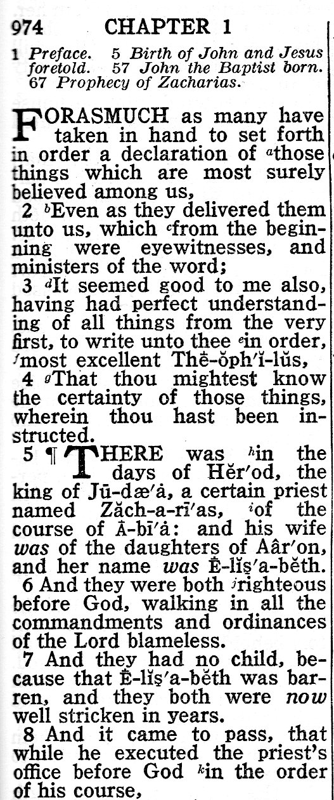 | Most modern translations format the verses into whole paragraphs, and they add titles to each section, as we see here in the New International Version (NIV).  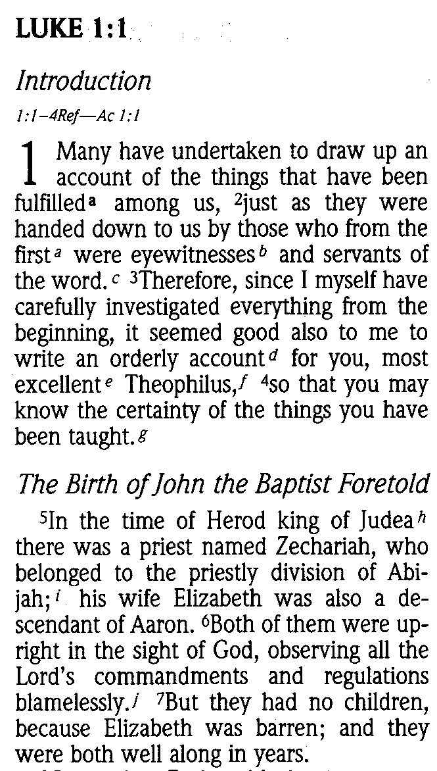

Lesson 14 – The best way to read and study the Bible
Watch Part 14 video.

1. Which is the best way to read and study the Bible? (Check the right answer.)
__ Each verse separately by itself
__ Whole paragraphs and chapters

2. Why is that the best way to read the Bible?

3. Some Bible versions (translations) have chapter headings.
How do those chapter headings help us study the Bible with greater understanding?

Lesson 15 – Meditating on Scripture
Watch Part 15 video.

1. What does it mean to meditate on a Bible verse? How should we meditate on Bible verses?

Read John 1:1–14
2. Who is “The Word”?

Read Matthew 18:20
3. As Christians come together to study God’s Word and prayer, who else also joins that group?

Lesson 16 – Divine Authorship of the Bible
Watch Part 16 video.

1. Today God communicates with us, how?

2. What is the most important thing that God tells us the Bible?

3. How is the Bible different than all other books?

4. If Moses and other people wrote various parts of the Bible, how is God the real author of the Bible?

Lesson 17 – How God Communicates With People
Watch Part 17 video.

1. The word REVELATION means what?

2. In Bible times, God communicated with people various ways. In the following verses, how did God communicate? (Circle the right answer.)

(a) Genesis 41:15–25
(angel - dream - prophet - vision - voice - writing)

(b) Exodus 24:12
(angel - dream - prophet - vision - voice - writing)

(c) Judges 6:7–10
(angel - dream - prophet - vision - voice - writing)

(d) Judges 6:11–12
(angel - dream - prophet - vision - voice - writing)

(e) 1 Samuel 3:1–10
(angel - dream - prophet - vision - voice - writing)

(f) Matthew 2:11–12
(angel - dream - prophet - vision - voice - writing)

(g) Luke 1:26–38
(angel - dream - prophet - vision - voice - writing)

(h) Acts 9:10–12
(angel - dream - prophet - vision - voice - writing)

(i) Acts 11:4–6
(angel - dream - prophet - vision - voice - writing)

(j) Acts 11:27–29
(angel - dream - prophet - vision - voice - writing)

Lesson 18 – Powerful Acts of God
Watch Part 18 video.

Match powerful acts of God with sections of the Bible that describe those acts:

(1) Genesis 1 & 2  (2) Exodus 12–14; 19–20  (3) 2 Chronicles 36:15–23  (4) Matthew, Mark, Luke,  and John  (5) Acts 2 | (a) God revealed Himself in His Son Jesus Christ, through His life, crucifixion, death, and resurrection.  (b) God freed His people from Egypt & gave His Law on Mt Sinai.  (c) God created the world.  (d) God sent the Holy Spirit’s power to the Disciples to help them preach about Jesus to the world.  (e) God punished Israel in the Babylonian captivity.

Lesson 19 – God’s Messengers
Watch Part 19 video.

Read Hebrews 1:1–3
1. In the Old Testament times, whom did God send to tell people about Him?

2. In the New Testament times, who showed us what God is like?

Lesson 20 – Why God gave us the Bible
Watch Part 20 video.

1. Why did God give us His Word, the Bible? (What is the MOST IMPORTANT reason?)

Read 2 Timothy 3:15–17
2. These verses list important ways the Bible helps us. Write that list here:

Lesson 21 – Inspiration of Scripture
Watch Part 21 video.

Read 2 Timothy 3:15–17
1. The word INSPIRIED has two different meanings:
(a) The world’s meaning

(b) The Bible’s meaning

Read John 6:66–69
2. In these verses, Peter says that Jesus’ words give us what?

Lesson 22 – Bible Writers
Watch Part 22 video.

Read 2 Peter 1:12–21
1. What were various occupations (jobs) of the writers of the Bible?

2. Why are their words in the Bible really God’s words?

3. It is important that we read and study the Bible every day. Why?

Lesson 23 – The Word of God
Watch Part 23 video.

This lesson describes four different meanings for “WORD OF GOD.”

(1) Read:
Psalm 33:6
Isaiah 55:10–11
2 Peter 3:3–7
In these verses “Word of God” means

(2) Read:
John 1:1 & 14
Revelation 19:11–16
In these verses “Word of God” means

(3) Read:
Ephesians 1:13
Colossians 1:3–5
In these verses “Word of Truth” means

(4) Read:
Ephesians 6:17
2 Peter 1:19
Hebrews 4:12
In these verses “Word of God” means

Lesson 24 – Authority of Scripture
Watch Part 24 video.

Read:
Luke 24:27 Acts 18:28
John 5:39 Romans 15:4
Acts 17:11

1. In what ways does the Bible have AUTHORITY?

2. How can we know if any religious teaching or doctrine is right or the teaching is wrong?

Lesson 25 – PRINCIPLES FOR INTERPRETING THE BIBLE
#1. Follow the intended meaning.
Watch Part 25 video.

1. What does it mean that we INTERPRET the Bible?

2. Bible students must use correct principles when they study the Bible.
Why is this is important?

Read Acts 6:7
See the sentence:
“So the word of God spread.” (NIV)
“So God’s word spread.” (NIRV)
“And the word of God increased.” (KJV)
“Then the word of God spread.” (NKJV)
“And the word of God continued to increase.” (ESV)

3. What does that sentence mean?

Lesson 26 – PRINCIPLES FOR INTERPRETING THE BIBLE
#2. Understand the difference between
LITERAL and FIGURATIVE (SYMBOLIC) text
Watch Part 26 video.

This lesson describes three kinds of symbolic figures of speech that we find in the Bible.

(a) SIMILE (pronounced: SIM-a-LEE).
compares two things, using the words “like” or “as” or “similar”.
Example: Psalm 1:1–4 (NIV)
Blessed is the one... whose delight is in the law of the Lord,
and who meditates on His law day and night.
That person is like a tree planted by streams of water...
Not so the wicked! They are like chaff that the wind blows away.

(b) METAPHORE (pronounced MET-a-FOR)
compares two things without using words “as” or “like” or “similar.”
Example: John 10:7–9
Jesus said, “I am the door [or gate] for the sheep.”

(c) PARABLE (pronounced PAIR-a-BUL)
a story that compares things on earth with things in heaven.
Example: Luke 15:4–6 The parable of the lost sheep

Often poetry (as we find in Old Testament psalms and prophets) uses picture language to describe a feeling or experience, mixing together both literal and figurative meaning.

Bible texts that describe visions of heaven or future events (like Ezekiel, Daniel, and Revelation) use strong symbolic pictures. When we read these hard texts, we must remember that those writers intended that their word-pictures have a figurative meaning.

QUESTIONS:
1. Read the Bible verses below and decide if they are literal or figurative:
(a) | Exodus 14:21–22 | __figurative | __literal
(b) | Psalm 23:1–2 | __figurative | __literal
(c) | Isaiah 55:1–2 | __figurative | __literal
(d) | John 2:19–21 | __figurative | __literal
(e) | John 13:4–5 | __figurative | __literal
(f) | Acts 28:1–6 | __figurative | __literal

2. Write the meaning for Jesus' symbolic words:
a) "I am the gate for the sheep."(John 10:7)

b) "You are the salt of the earth...You are the light of the world..." (Matthew 5:13–16)

A SIMILE compares two things, using the word like or as.
Read Matthew 13:44–46.
3. Here Jesus compares what?

v. 44 ______________________ is like

v. 45 ______________________ is like

Read Luke 8:4–8.
4. Explain the word pictures in this parable. (Hint: Read Luke 8:11–15.)

(a) the seed =

(b) the seed falling on the path =

(c) the seed on the rocky place =

(d) the seed among the weeds (thorns) =

(e) the seed falling on good soil =

Lesson 27 – PRINCIPLES FOR INTERPRETING THE BIBLE
#3. Read and understand every verse of the Bible in its CONTEXT
Watch Part 27 video.

1. How do we read a Bible verse in its context?

Read Matthew 24:40–42.
2. These verses teach about the second coming of Jesus Christ. Many Christians swallow false teaching about these verses because they forget to read the context.
a. Those who are “taken” = __ saved people. __ unbelievers(lost people).
b. Those who are “left” = __ saved people. __ unbelievers (lost people).
IMPORTANT HINT: Read the context (verses 37–39).

3. What is the most important teaching of the Bible?

Lesson 28 – PRINCIPLES FOR INTERPRETING THE BIBLE
#4. Interpret Scripture in harmony with itself
Read and understand every verse as it fits with every other verse of the Bible
Watch Part 28 video.

Read:
Psalm 23
John 10:11–18
1 Peter 2:24–25

1. How do John 10 and 1 Peter 2 help us understand Psalm 23?

Read:
Genesis 1:1
Psalm 33:6
2 Peter 3:3–7

2. What is the connection between the way the world began and the way the world will end?

3. What do these verses teach us about the power of God’s Word?

Lesson 29 – PRINCIPLES FOR INTERPRETING THE BIBLE
#5. Interpret Scripture Christologically (Christ focus)
Watch Part 29 video.

Read John 5:37–40
1. Where in the Bible do we find the Gospel about Jesus Christ?
__ Old Testament
__ New Testament
__ The whole Bible – both OT and NT.

2. Study the following prophecies of the Old Testament and their fulfillment in the New Testament. Write down what was fulfilled:

PROPHECY  What will happen | FULFILLMENT  What happened
Isaiah 7:14 | Matthew 1:18-25
Psalm 78:2 | Matthew 13:34,35
Zechariah 11:12-13 | Matthew 27:3-9
Joel 2:28–32 | Acts 2:1–21

Read Genesis 12:1-3
3. God made a four promises to Abram (Abraham).
(a) What was the last thing that God promised to Abram?

(b) How is that promise fulfilled by Jesus Christ?
(Hint: Read Matthew 1:1 and John 3:16.)

Read:
Numbers 21:4–9
John 3:14

4. How do the following points in the Old Testament snake story apply to our connection with Christ?

(a) The people rebelling =

(b) The people's sickness & death =

(c) The snake on the pole =

(d) The way people were healed =

Lesson 30 – Tools for Understanding the Bible
Watch Part 30 video.

1. As we study the Bible, we must analyze each verse to see where that verse fits into two important categories:

_______________ or ________________

2. The last part of this lesson names two kinds of tools we use to study the Bible:

(a)

(b)

In the next eleven lessons we will explain more about those tools
and you will practice using those tools.

Lesson 31 – TOOLS FOR UNDERSTANDING THE BIBLE
Language & Grammar
Watch Part 31 video.

The Old Testament was written mostly in Hebrew & a little bit of Aramaic (which is a lot like Hebrew).

The New Testament was written in Greek (often called “Koine” [pronounced KOY-NAY] Greek, meaning “common” Greek.

After we recorded this course, more English translations became available:
New International Readers Version (NIRV) is the Bible in easy English, similar to the English Version for the Deaf.
English Standard Version (ESV) is similar to NKJV (New King James Version).
ASL Bible online from deafbible.com (or deaf.bible)

Online Bible study tools
biblegateway.com biblehub.com blueletterbible.org

Concordance exercise
For questions #1 and #2 below, use a concordance (look in the back of your Bible) or use an online Bible search website, like www.biblegateway.com/keyword
1. Find three Bible verses that talk about FAITH.

(a)

(b)

(c)

2. Where in the Bible is the story about David adultery with Bathsheba? (What chapters?)

Read:
Mark 1:16–18
Luke 10:1–3
Matthew 28:19,20.

3. What points in these three Bible texts are similar (the same)?

4. What information in these three Bible texts is different?

Lesson 32 – Historical Background Tool
Watch Part 32 video.

Read Luke 1:1–5
1. Luke wrote his gospel for whom? (verse 3)

2. From whom did Luke get his information about Jesus? (verse 2)

3. Luke’s gospel about Jesus began at what time in Israel’s history? (verse 5)

Read Luke 2:1–7
4. Who was ruler of the Roman world when Jesus was born?

5. The Roman emperor made a political decision that affected Mary and Joseph at the time of Jesus’ birth. What was the emperor’s command?

6. Why did Joseph and Mary go from Nazareth to Bethlehem?

7. Look at a New Testament Bible map:

(a) Where in Israel is Nazareth?

(b) Where in Israel is Bethlehem?

(c) What is the distance between Nazareth and Bethlehem?

(d) Why did Mary and Joseph lay baby Jesus in a manger (animal feeding box) instead of a normal bed?

Read Galatians 1:1–6
8. Who wrote this letter?

9. To whom did he write this letter? (verse 2)

10. What serious problem did these people have?

11. Who made Paul become an Apostle?

Lesson 33 – The Tool of Culture
Watch Part 33 video.

1. Describe some differences between Deaf culture and Hearing culture.

Read Ruth 4:1–10
This story describes many things in the culture of that time and place, things that we don’t do in our culture today.

2. Make a list of those different cultural practices in this story.

Read 1 Corinthians 9:19–23
Paul understood that we must understand differences in cultures when we want to share the Gospel with other people.

3. What Paul do did to introduce people in various cultures to Jesus.

To get a deeper understanding about the culture in Bible times,
study the DeafPah course: “Everyday Life in Bible Times.”

Lesson 34 – Theological Tools
Watch Part 34 video.

1. What are the two chief teachings of the Bible?

(a)

(b)

2. Summarize each of those teachings in one or two sentences:

(a)

(b)

Lesson 35 – The Law of God: “Curb”
Watch Part 37 video.

Read Romans 13:1–5
How is the Law of God like a “curb”?

Lesson 36 – The Law of God: “Mirror”
Watch Part 36 video.

Read:
Romans 3:19–20
Romans 7:7
How is the Law of God like a “mirror”?

Lesson 37 – The Law of God: “Guide”
Watch Part 37 video.

Read Psalm 119:9–11
How is the Law of God like a “guide”?

Lesson 38 – Three Functions of the Law
Watch Part 38 video.
Read these Bible texts. Check if they use the Law as a curb, mirror, or guide.
1. Psalm 119:10- 106 __Curb __Mirror __Guide
2. Proverbs 24:21-22 __Curb __Mirror __Guide
3. Romans 3:20 __Curb __Mirror __Guide
4. Romans 7:7 __Curb __Mirror __Guide
5. Galatians 6:2 __Curb __Mirror __Guide
6. Ephesians 5:15-20 __Curb __Mirror __Guide
7. 1 Peter 2:13-14 __Curb __Mirror __Guide

Lesson 39 – Law and Gospel
Watch Part 39 video.
Check each statement as LAW or GOSPEL
1. __Law __Gospel: Teaches what we are to do and not to do.
2. __Law __Gospel: Teaches us what God has done, and still does, for our salvation.
3. __Law __Gospel: Shows us our sin and the anger of God.
4. __Law __Gospel: Shows us our Savior and the grace of God.
5. __Law __Gospel: Must be preached to everyone, but especially to sinners who are not repenting.
6. __Law __Gospel: Must be preached to sinners who are sorry about their sins.

Check each text as LAW or GOSPEL
7. __Law __Gospel Matthew 23:27–28
8. __Law __Gospel Mark 7:20–23
9. __Law __Gospel John 10:14–18
10. __Law __Gospel Acts 2:37–39
11. __Law __Gospel Romans 1:16
12. __Law __Gospel Romans 1:18
13. __Law __Gospel Romans 5:1
14. __Law __Gospel Ephesians 2:7–8
15. __Law __Gospel Colossians 1:13–14

Carl Ferdinand Wilhelm Walther (“C. F. W. Walther”) was a Lutheran pastor who came with a group from Germany to the United States in 1839. They settled in two communities in Missouri near the Mississippi River – in the city of St. Louis and also south in Perry County.
Walther and his group established a log-cabin college which grew to become Concordia Seminary in St. Louis. He also helped to unite his group with other German immigrant churches into The German Evangelical Lutheran Synod of Missouri, Ohio, and other States – today it is called The Lutheran Church—Missouri Synod (LCMS). In 1847 this new denomination elected Walther as their first president.
In 1884 and 1885 Walther gave a series of lectures at the seminary, teaching his students about Law and Gospel. Those lectures have been translated from German to English and are now published by Concordia Publishing House (www.cph.org) in a book titled The Proper Distinction Between Law and Gospel. This book is a very helpful resource to help us clearly understand and apply the Bible’s teaching of Law and Gospel.

Lesson 40 – Justification and Grace
Watch Part 40 video.

Read:
Romans 3:21–26
Ephesians 2:8–9
1 John 1:5–10

1. What does JUSTIFICATION mean?

2. What does GRACE mean?

3. The Bible teaches that God justifies us by grace through faith.
What does that mean?

Lesson 41 – Rightly Dividing the Word of Truth
Watch Part 41 video.

Read 2 Timothy 2:15 in various English versions on your Bible app, or on biblegateway.com. Read this verse in:
ESV (English Standard Version)
NIV (New International Version)
NIRV (New International Readers Version)
NKJV (New King James Version)

1. How does a student of the Bible “rightly divide the word of truth”?

Read Romans 6:23
2. Which words of this verse teach Law?

3. Which words of this verse teach Gospel?

Read John 3:14–18
4. Which verses of this text teach Law?

5. Which verses teach Gospel?

Read and compare:
2 Corinthians 5:17–19
John 3:1–17
6. 2 Corinthians 5 says, “The old has gone, the new has come.”
What does that mean?

Lesson 42 – Important Old Testament Concepts
Watch Part 42 video.

Read Deuteronomy 6
1. This chapter summarizes important Old Testament concepts.
List the most important concepts in this text:

(a) verse 1–2

(b) verse 4

(c) verse 5

(d) verse 7

(e) verse 14

2. What are some other important lessons that the Old Testament teach us?

3. What is the main goal of the whole Bible, both Old Testament and New Testament?

Lesson 43 – Important New Testament Concepts
Watch Part 43 video.

Read:
John 20:30–31
2 Corinthians 5:20 – 6:2
1 John 1:1 – 2:2

What is the basic goal of the New Testament?

Lesson 44 – Analyzing and Understanding History
Watch Part 44 video.

Read:
Luke 1:51–52
Jeremiah 18:1–10
1. God used the example of a potter to teach Jeremiah a lesson about what?

Read:
Matthew 28:1–15
John 20:1–18
2. Compare those two stories about Jesus’ resurrection:
(a) How are the two stories the same?

(b) How are the two stories different?

(c) How do both stories together give us better understanding about Jesus’ resurrection?

Lesson 45 – Analyzing and Understanding Prophecy
Watch Part 45 video.

The Prophet’s work
Read:
Isaiah 42:18–25
Isaiah 58:1–8
Ezekiel 16:1
Jonah 1:1–2
Haggai 1:1–8

1. The prophets received their message from whom?

2. What was the prophets’ main work?

Intended Meaning
LITERAL PROPHECY
Read Jeremiah 25:1–14
3. The Lord said what will happen to the land of Judah?

4. How many years will the people of Israel serve the King of Babylon?

5. Then what will happen to Babylon?

FIGURATIVE PROPHECY
Read Ezekiel 37:1–14
6. Ezekiel saw a vision of dry bones. Those bones represented whom?

7. Those bones in Ezekiel’s vision became living humans. That represented what?

Read Isaiah 53
8. The following New Testament verses point to Isaiah’s prophecy. Write the number of the verse from Isaiah 53 we find in each the following New Testament texts. (The first one is done for you as an example.)
(a) Matthew 8:16–17 →Isaiah 53:_4__
(b) Matthew 27:57–60 → Isaiah 53:____
(c) John 1:10–11 → Isaiah 53:____
(d) John 12:37–38 → Isaiah 53:____
(e) Acts 8:26–37 → Isaiah 53:____
(f) Romans 5:18–19 → Isaiah 53:____
(g) Romans 8:34 → Isaiah 53:____
(h) 1 Peter 2:21–22 → Isaiah 53:____
(i) 1 Peter 2:24 → Isaiah 53:____
(j) 1 Peter 2:25 → Isaiah 53:____

Lesson 46 – Analyzing and understanding Poetry in the Bible
Watch Part 46 video.

(1) Read Psalm 145:8
(a) Explain how the two lines are similar:

(b) Explain how they are different:

(2) Read Psalm 145:10
(a) Explain how the two lines are similar:

(b) Explain how they are different:

(3) Read Psalm 145:20
(a) Explain how the two lines are similar:

(b) Explain how they are different:

(4) Read:
Psalm 22:1–18
Matthew 27:35–46

(a) Psalm 22 is a messianic psalm because it has prophecy about Jesus Christ in future years. What specific things did Psalm 22 predict about Jesus’ crucifixion?

(b) Psalm 22 has both LITERAL and FIGURATIVE language.
Describe some of the figurative word-pictures in Psalm 22.
(Example: verse 6. “I am a worm and not a man.”)

(5) Read Proverbs 15:13
Find the first part and the second part of this verse. Write two things from the first part that are "opposite" of two things in the second part:

1st Part 2nd Part

(a)________________________ is opposite of ________________________

(b)________________________ is opposite of ________________________

Lesson 47 – Analyzing and Understanding the Gospels
Watch Part 47 video.

1. Names the four gospel writers:

(a)________________________ (b)________________________

(c)________________________ (d)________________________

Read Matthew 10:2–4
2. Which of the gospel writers belonged to Jesus’ 12 Disciples?

(a)________________________

(b)________________________

Read Matthew 9:9–13
3. What was Matthew’s job before Jesus called him to follow?

Read Acts 12:25
4. Mark help two men in their work. Who were those two men?

(a)________________________

(b)________________________

Read Colossians 4:14
5. What was Luke’s job?

Read Matthew 4:18–22
6. What was John’s job before Jesus called him to follow?

Read:
Matthew 1 – 2 (two chapters)
Mark 1 (one chapter)
Luke 1 – 2 (two chapters)
John 1 (one chapter)
7. Which two gospels describe the things that happened during Jesus’ birth (the Christmas story)?
(a)________________________

(b)________________________

8. Those two gospel versions of the Christmas story have some information that is the same in both, and they have information that very different.

(a) What information in those two gospels is the same in both?

(b) What information in those two gospels is different?

(c) Make a guess as to reason that the two gospels are different in the way they tell the Christmas story.

9. Which two gospels report Jesus’ genealogy (family tree)?

(a)________________________

(b)________________________

10. Which gospel tells about something that happened when Jesus was a young boy?

Read:
Matthew 1:22 Matthew 2:23 Matthew 12:17
Matthew 2:15 Matthew 4:14 Matthew 13:35
Matthew 2:17 Matthew 8:17 Matthew 27:9

11. What sentence or phrase did Matthew often use in his gospel?

12. What point was Matthew trying to prove when he wrote that phrase?

Read Matthew 28:18–20
13. This is the Great Commission. Write a summary of these verses in your own words: Jesus sends us to do....what?

Read Luke 1:1–4
14. Why did Luke write his gospel about Jesus?

Read John 20:30–31
15. Why did John write his gospel about Jesus?

16. What is the benefit of having four different gospel reports about Jesus’ life (instead of having just one gospel)?

Lesson 48 – Analyzing and Understanding the Epistles
Watch Part 48 video.

1. The word “epistle” means what?

2. The video lesson describes five parts to the form of New Testament epistles. What are those five parts:
(a)________________________ (b)________________________

(c)________________________ (d)________________________

(e)________________________

3. Read the first few verses in each of the New Testament epistles. Identify who wrote the letter and to where or to whom he sent the letter:
Read chapter 1: | This letter is FROM whom? | This letter is TO where or whom?
Romans | v.1 | v.7
1 Corinthians | v.1 | v.2
2 Corinthians | v.1 | v.1
Galatians | v.1 | v.2
Ephesians | v.1 | v.1
Philippians | v.1 | v.1
Colossians | v.1 | v.2
1 Thessalonians | v.1 | v.1
2 Thessalonians | v.1 | v.1
1 Timothy | v.1 | v.2
2 Timothy | v.1 | v.2
Titus | v.1 | v.4
Philemon | v.1 | v.1–2
Hebrews | (unknown) | (To Jewish Christians in Rome)
James | v.1 | v.1
1 Peter | v.2 | v.1
2 Peter | v.1 | v.1
1 John | John the Apostle | (not identified)
2 John | v.1 | v.1
3 John | v.1 | v.1
Jude | v.1 | v.1

4. Who wrote most of the letters in the New Testament?

Read Romans 1:10–13
5. Why did Paul write this letter to the Christians in Rome?

Read Romans 1:17
6. What is the theme of Paul's letter to the Romans?

Read 1 Corinthians 1:10–11
7. Why did Paul write this first letter to the Corinthians?

Read 2 Corinthians 1:3–7
8. Why did Paul write this second letter to the Corinthians?

Read Galatians 1:6–9
9. Why did Paul write this letter to the Christians in Galatia?

Read Philippians 4:14–19
10. Why did Paul write this letter to the Christians in Philippi?

Read 1 Thessalonians 4:13 – 5:11
11. What important teaching did Paul give the Christians in Thessalonica?

Read Philemon 10–16 (or Philemon 1:10–16 in internet Bibles)
12. Who was Onesimus?

Read Hebrews 1:1–2
13. The Letter to the Hebrews is about whom?

Final Exam

Read Acts 17:10–12
1. Describe the Bereans’ attitude about God’s Word.

Read Deuteronomy 6:6–9
2. What should be our attitude about the Bible?

Read Matthew 6:25–34
3. A teenager and a senior citizen may read these verses in different ways, as they apply Jesus’ words to their lives.
(a) What might these verses say to a teenage Christian?

(b) What might these verses say to a senior citizen?

Read 2 Corinthians 13:12
3. Paul tells Christians to "greet one another with a holy kiss."
How may this passage be applied in the "culture" in church fellowship today?

Three basic steps of Bible study are
1) Observation (“What does the Bible text say?”)
2) Interpretation (“What does the Bible text mean?”)
3) Application (“What does the Bible mean to me?”)

Select ONE of the texts below. Use these steps in your study of this passage:
Psalm 23:1
Psalm 23:4
Matthew 7:15–20
Romans 8:37–39

5. The text I chose is _______________________

6. What does the text say? (in your own words)

7. What does this text mean?

8. What does this text mean to me?

How We Got the Bible
from DeafPah! course:
“Everyday Life in Bible Times”

Long ago in ancient times, when a king gave a formal announcement, his statement was engraved (carved) in stone, like we see on many old buildings and also the Ten Commandments.

But chiseling stone is no good for everyday writing. So what did they do? How did they write?

During Abraham’s time, people in the Middle East wrote on clay tablets. While the clay was still wet, they had a stick they pressed into the clay. When the writing was finished, they let the clay dry in the sun. Then they put the clay tablet in fire to make the clay hard and the writing permanent.

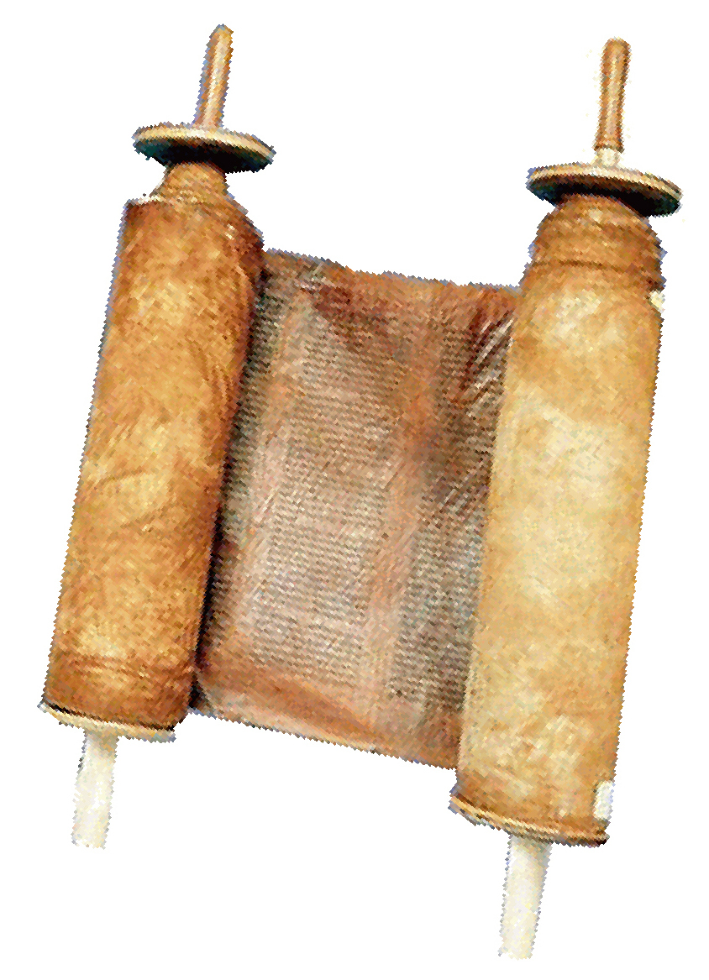
But during Israel’s time, they wrote their history, their stories, their letters, their songs, and their contracts not on clay and not on stone. They wrote on animal skins – sheep or goats.

They scraped the skin very clean and very thin almost like paper.
That animal skin for writing is called parchment.

The Hebrew language is written right to left. They wrote in columns.
When the ink was dry, they rolled up the parchment. That made a scroll.

And when they needed to add more columns, they sewed on another animal skin. That made the scroll longer. Parchment scrolls could be 10 – 30 feet long.

Animal skins are really wonderful for writing, because they stay good thousands of years. Our oldest Bible scrolls that we have found, are written on animal skins. Those Old Testament Bible scrolls are called the Dead Sea Scrolls.

Today we use paper for writing. Back during Bible times, Egyptians made paper from tall grass that grew in water. That grass was called papyrus.

They lay the grass stalk side by side. Then they lay a second layer of grass, perpendicular to the first, like a thin mat. When that was finished, they pressed the grass mat and let it dry. Then the trimmed the edges straight Papyrus became like paper for writing a letter.

The prophets, poets, and historians of the Old Testament wrote on parchment. New Testament writers probably used both parchment and papyrus. Papyrus was cheap, but it quickly fell apart. Animal skin parchment remains good a long time.

Scribes
Long ago, people did not have printing presses. They did not have copy machines. No Xerox machines. They did not have computers, email, or printers. All writing was done by hand.

A scroll that has writing is called a manuscript,, which “hand written.” And a person that does writing for his work, his job, that person is called, a scribe, a “writer.”

Professional scribes worked for kings and government officials, writing laws and history. Scribes in Israel were responsible for copying God’s Word, and they taught God’s people.

Also, when Paul wrote his letters in the New Testament, Paul did not write those letters himself. He spoke while a friend wrote for him. Then at the end, Paul wrote his short personal greeting, like a signature.

Scribes wrote using pen and ink. The pen was a thin wood stick, or a grass stalk. Ink was kept in a cow’s horn that had a cap.

Bible copies vs. original manuscripts
When the Apostle John wrote his New Testament letters, John wrote on parchment or papyrus. Other people wanted share or have their own copy of John’s letters, so they read it line by line, and as they read it, they wrote their own copy. Many people did that, so many churches had hand-written copies of John’s letters. Then more people wanted copies of John’s letters, so they made their own copies from earlier copies.

Every time someone makes a handwritten copy of someone else’s letter, the copyist may make a mistake – accidentally change a word or leave a word out. That could be a problem, because somehow, somewhere the letters that John wrote himself (the original manuscripts) were lost or destroyed. All we have left are thousands of handwritten copies of his letters.

So we must ask the question: Are those copies of John’s letters accurate? Do the say exactly what John wrote in the original manuscript?

Absolutely YES! We have so many copies that were made soon after John’s original writing, it is easy figure out what John wrote. (See the article about the reliability of Scripture later in this appendix.)

Scrolls vs Books
When you read the Bible, New Testament, often you read the word “book.” The Greek word is biblios, and that word means book.

Today when we see that word “book,” we visualize a normal book with pages. Wrong. They did not have books in Bible times. They had scrolls. Books were not invented yet. So when you read the word “book” in the Bible, visualize a scroll, not a book.

When did scrolls change to books?

Remember that Hebrews in the Old Testament wrote on animal skin scrolls. They wrote from right to left, and they arranged there columns from right to left. Greeks and Romans wrote from left to right, and they also arranged their text into columns. When they needed more columns, they sewed on more animal skin parchment.

If you wanted to bring your Bible to a meeting, you carried an armload of scrolls. If you wanted to find a specific chapter or verse, you must unroll the scroll, until you find the verse. Then when you wanted to find another verse, you must roll the scroll again. That wastes a lot of time.

Jewish people solved that problem by memorizing a lot of God’s Word. So they did not always need to look up verses. But that did not help Christians in Greece, Italy, and other countries.

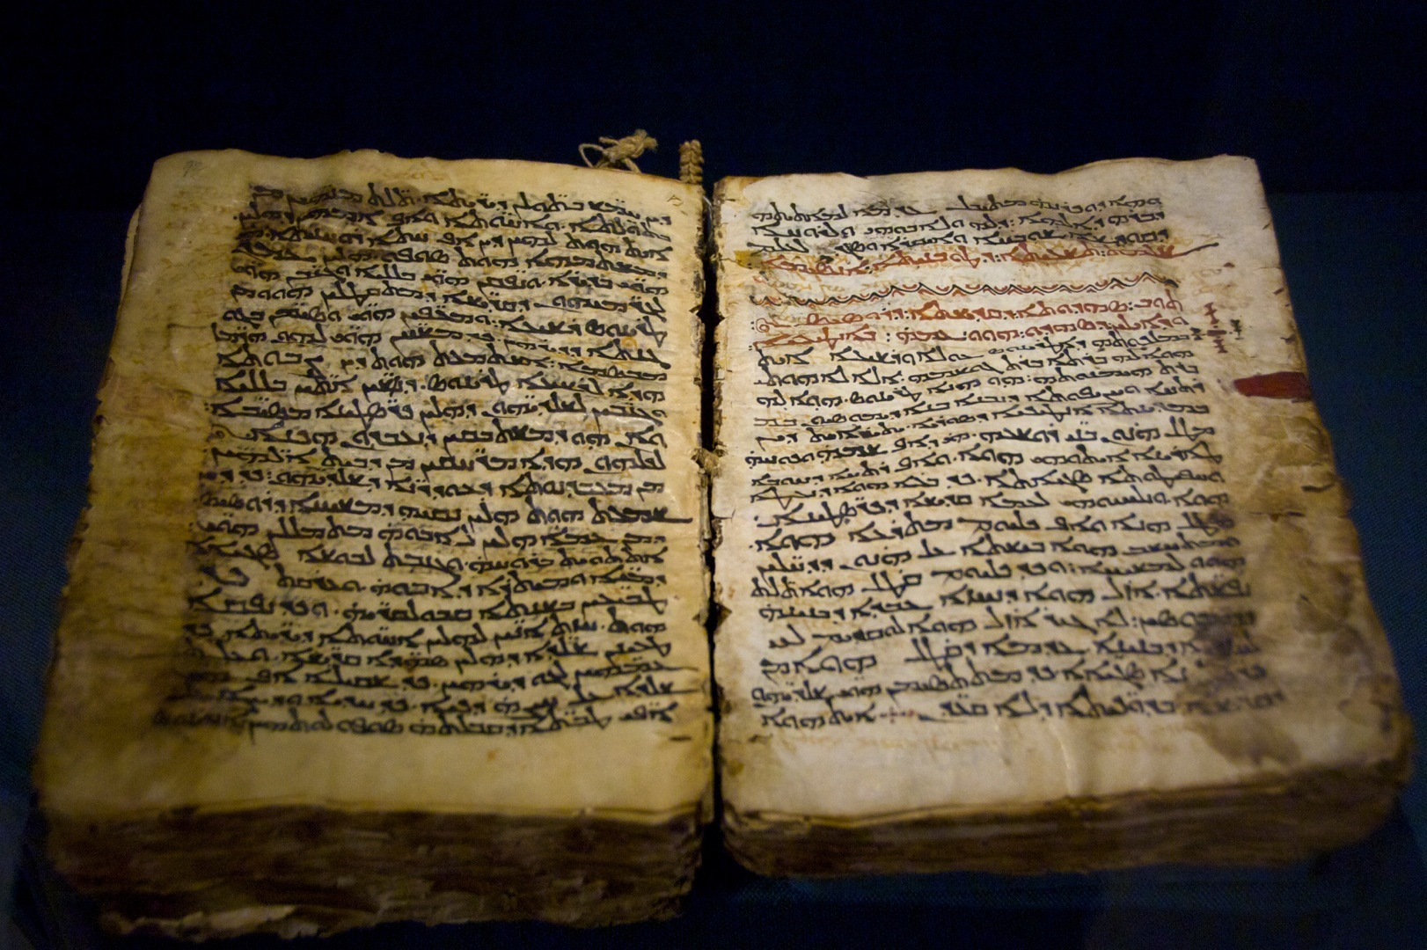
So the Romans invented a good trick.

If we open a scroll – unroll it – and use a sharp knife to cut the scroll between each column of text., then stack the pieces of parchment, and sew or glue left side of the stack and cover it, when you finish, you have a book. It is easy to flip pages to find verses. And you can carry a book more easily than scrolls.

Also, on scrolls you can write only on one side of the parchment. But you can write on both sides of book pages.

The formal name for “book” is “codex.”

But always remember, when you see the word “book” the Bible, visualize a scroll

The Canon of Scripture
by Rev. Ron Friedrich

Who chose the books to include in the Bible?
No one... and everyone. I will explain...

This question assumes that the Bible was compiled by a person, or a committee, or a convention of church leaders. No, that is not how it happened. Nor was there a secret organization that ran all over the Roman Empire cutting out so-called "banned" books from the Bibles in every church and in Christian homes. None of that happened.

What DID happen?

As godly Jewish people read the messages of the prophets, the prayer-songs (psalms) of David, and the history of Israel (from God's point of view), the people all over Israel recognized that those writings were inspired by God, and they were different than all other songs and histories. The people of Israel called these writings the Torah and Tanach -- the Scriptures. Christians call them the Old Testament.

Centuries later when Christian people shared and read the letters of Paul, Peter, and John, those readers understood that they were not reading just any ordinary letters; these letters were the Word of God, Himself!

A lot of people wrote a lot of "gospel" stories about Jesus. Something did not seem right about most of those stories. Only the gospels of Matthew, Mark, Luke, and John taught the truth of God's grace in Jesus Christ. True believers all over the Middle East, Europe, and North Africa recognized that these four gospels also are the Word of God, and they universally rejected the fake gospels.

Today we call the collection of those gospels and letters the New Testament. The 39 books of the Old Testament and 27 books of the New Testament are the "canon" of the Bible. (Canon is a Greek word that means "rule" or "list.") The New Testament canon of 27 books developed gradually, until it was widely accepted about the year AD 100. Since then church councils meeting to respond to spreading heresy occasionally affirmed the canon of Scripture.

Why do Catholic Bibles have 81 books? Our Bible has only 66 books.
The 66 books of the Bible with which you are familiar are the 39 books of the Jewish Scriptures, which we call the Old Testament, and 27 books of the New Testament. If you look in a Roman Catholic Bible, you will find in some copies a third part, between the OT and NT, called the Deutero-cononical books or Apocrypha. (Find that word in a dictionary and read what it means.)

Books in the Apocrypha were mostly written in Israel during the time gap between the OT and NT. It has Jewish history, prayers, poetry, advice for godly living, visions, and some fictional additions to the OT books of Ezra, Daniel, and Esther.

For many centuries, the authoritative translation of the Bible for the Catholic Church was the Latin Vulgate, attributed to St. Jerome. Jerome himself did not believe the Apocrypha should be included in the Bible. But church leaders ignored Jerome's advice and they added the Apocrypha to Jerome's Latin translation.

The 16th Century Protestant Reformers confessed their faith based on the 39 books of the Old Testament Hebrew Scripture and 27 books of the New Testament. Catholic bishops responded at the Council of Trent by emphatically affirming that they also included the Apocrypha.

After Luther translated the Bible from the original Hebrew and Greek into the German language, Luther's friend Philip Melanchthon translated the Apocrypha. Some early publications of the German Bible included the Apocrypha between the OT and NT. Martin Luther said about the Apocrypha: "These books are not held equal to the Scriptures, but are useful and good to read."

Some modern publications of the Catholic Bible mix books of the Apocrypha in with the Old Testament, so that the average reader is not able to discern the difference.

Getting the Bible in Our Own Language

Old Testament scrolls were written on parchment scrolls, one scroll for each book of the Bible. They were kept in the synagogues. The text was written by hand in the Hebrew language, and small parts in the Aramaic language (similar to Hebrew)

In the year 285 BC Hebrew scribes and rabbis began translating the Old Testament scrolls into the Greek language, a task that took over 100 years to complete. According to Jewish tradition, the translation was done by 72 translators, six from each of the 12 tribes of Israel. From this tradition, the Greek translation of the Old Testament is called the Septuagint and is commonly abbreviated as LXX (Roman numeral 70). The Septuagint was the translation that Greek speaking Jews used during the time of Jesus and the Apostles. The Apostles and Gospel writers often quoted from this Greek translation of the Old Testament.

The Apostles and Gospel writers wrote the New Testament in the Greek language. When they quoted the Old Testament, they usually quoted from the Greek Septuagint translation.
In AD 410 Jerome translated the Hebrew Old Testament and the Greek New Testament into Latin, the official language of the Roman Empire. Jerome’s Latin Bible was called the Vulgate translation and it became the officially accepted translation of the Roman Catholic Church. After the fall of the Roman Empire, the Latin language faded, so many generations of Christians did not have the Bible in their own languages.

In 1521 Martin Luther translated the Hebrew Old Testament and Greek New Testament into the German language. The invention of the printing press made it possible for many copies to be printed quickly, so everyone in Germany had the opportunity to read God’s Word for themselves in their own language.

About the same time Luther offered his German translation of the Bible, William Tyndale in England began translating the Bible from the original Greek and Hebrew texts into the English language. His work was banned by the Church of England and by King Henry VIII. They condemned Tyndale as a heretic and had him killed before he was able to finish translating the Old Testament. His friend Miles Coverdale complete Tyndale’s work and published the first complete English Bible in 1537.

King James of England wanted the British people to have solid, up to date English translation of the Bible. He assigned the task to 54 Greek and Hebrew scholars. They completed their work and published the King James Version (KJV) in 1611.

Since the English language has changed since the days of King James, scholars offer us today fresh translations of Scripture in our own language.

Evidence for the Reliability of Scripture
by Rev. Ronald Friedrich

One criticism that atheists and agnostics often throw at Christians is this:
"The Bible has been translated so many times,
there is no way to know if it is accurate."
That popular criticism exposes a basic misunderstanding of how the Bible comes to us in the English language. The criticism assumes that we got our English Bible from an earlier translation, and that translation came from a translation from before that, like this:
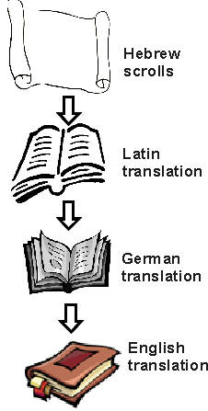

Is that how we got the Bible? No! The real picture looks more like this:
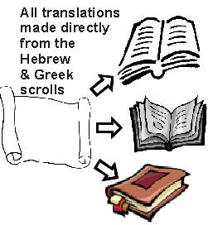
The Old Testament texts were originally written in Hebrew, and the New Testament was written in Greek. When scholars translate the Bible into English, they do not translate from another translation. They translate directly from the ancient Greek and Hebrew texts.
So why do many English versions look so different? Greek and Hebrew are not the same as English, just as ASL is not the same as English. Just as five different ASL interpreters may express the same idea in five different ways that all mean the same thing, so also Bible translators must choose the best way to most clearly communicate the meaning of the ancient text in a language people understand today.
Different translators may choose different ways to express the same idea. While Bible translators do not have the any of the original documents written by Moses, David, or Paul, we do have available to us thousands of ancient carefully handwritten copies (manuscripts) made in the early years after the composition of the original documents.
How reliable are those manuscript copies? We answer that question next...
Another false criticism that atheists and agnostics often throw at Christians is this:
"The scribes who copied the Bible by hand made mistakes."

Gutenberg’s printing press and Xerox's photocopy machine are wonderful inventions that have changed the world of communication. Both are a blessing... and a curse. They are a curse, because every day those machines reproduce thousands of typographical errors.
Recently I read a book that appears to have bypassed the proofreader. There was a typographical error on nearly every chapter. When I read the first edition of the same book many years ago, it did not have those typos. Even if I didn't have that first edition copy, it was obvious what the original author wrote in spite of the typesetter's many mistakes. Furthermore, none of the typographical errors changed the meaning, or even the nuance, of the original text.
This is a similar situation we face when we translate the Bible from ancient Greek and Hebrew manuscripts (handwritten copies). We don't have the benefit of possessing Jeremiah's original scrolls, nor do we have the actual original letters which Paul wrote to the churches in Europe and the Middle East. What we do have are thousands of handwritten copies of copies of copies... And we can see some differences among those copies. Are the differences serious enough to cast doubt on the accuracy of the manuscripts? Let's look at three typical examples.
(1) Some copyist changed the word order of a sentence. For example, Matthew 1:18 begins, "The birth of Jesus Christ..." But many ancient copies say, "The birth of Christ Jesus..." And a few less reliable copies say, "The birth of Jesus..." or "The birth of Christ..." So which is correct? A majority of the most reliable manuscripts say "Jesus Christ." But does it really matter? Does changing the Greek word order change the meaning of the sentence? No.

(2) Some copyist changed the spelling of words. Sometimes this was accidental. Sometimes it was deliberate, as we do in our English translations of the Bible. Americans spell "Savior", but the British spell "Saviour." The Greek copyists did the same, adopting regionally accepted spelling of words, without changing their meaning.

(3) Some copyists accidentally left words out of a sentence. But any sensible reader can figure out what the missing word is (just as many of our newsletter readers do every month, when they find my many typos). Plus we have the advantage of comparing thousands of ancient manuscripts, which help us fill in an occasional missing word and correct a random misspelling in any particular copy.
Because we have so many ancient manuscripts of the Bible, the task of determining what Matthew, Mark, Luke, and John actually wrote is not very difficult. Furthermore, if you examine even the most questionable variations among the manuscript copies, you will not find one variant that challenges a single Biblical doctrine.
I have friends who say that they lack confidence in the Bible's authority because they believe that the copies from which the Bible is translated are inaccurate and unreliable. However, they are unable to identify ONE manuscript variant which casts a shadow on the Bible's accuracy. The truth is, those who "doubt" simply don't like what the Bible says, so they grab any excuse they can for a reason to justify unbelief.

[Continued on the next page...]
Testing the reliability and accuracy of ancient documents.

Plato -- the Greek philosopher.
Homer -- the Greek poet.
Julius Caesar -- the Roman emperor.
Tacitus -- the Roman historian.
Every student of ancient European history recognizes these names. When I studied Classical Greek and Latin in college, my fellow students and I had to translate portions of literature which these people had written. Handwritten manuscript copies of their work, copied and recopied generation after generation, still exist today, preserved in museum vaults.
In all my studies of these ancient authors, I never saw any critique which suggested that any of those documents are corrupted and unreliable. Scholars assume that the works of Plato, Homer, Caesar, and Tacitus which have been handed down to us accurately represent what their original authors wrote. Yet many of these same scholars claim that manuscript copies which form our New Testament of the Bible are corrupted and unreliable. In the face of such criticism, let us make a comparison, applying the same tests to the New Testament as we do other ancient documents.
Since we do not possess the original letters by Paul, or Plato's original manuscript, we must apply two basic tests to judge the accuracy of existing copies of an ancient document. Those two tests are:
(1) | How many ancient copies of the document still exist? If the number of existing copies is few, that is bad. If the number of existing copies is many, that is good. If we have many copies of a document, it is a simple task to compare those copies to determine what the original manuscript said.
(2) | How long is the time span between the original composition of the document and the earliest existing copies? A short time span is good. A long gap in time is bad. During a long span of time there is the chance that with each generation the text will become further corrupted.
How do the existing manuscripts of our ancient authors compare when we measure them with those two basic tests?
Plato wrote his Philosophy about 400 BC. Only seven ancient copies exist today. The time span between Plato and the earliest existing copy is about 1,300 years.
Homer wrote the Iliad about 800 BC. There are 642 ancient copies still in existence. The time span between Homer and the earliest existing copy is about 400 years.
Julius Caesar wrote his account of the Gallic Wars between 100 BC and 44 BC. Ten ancient copies still exist. The earliest of those copies was written 1,000 years after Caesar wrote original manuscript.
Tacitus wrote his Annals around AD 100. Twenty ancient copies exist, the earliest of which dates about 1,000 years after Tacitus.
In this list thus far, Homer gets the high score. He has the highest number of ancient manuscripts in the shortest time span. The others offer very few copies, with time spans of 1,000 years or more. Yet, historians have regarded the documents as accurate.
How do the Bible's New Testament manuscripts compare? There exists today 5,366 ancient copies of portions of the New Testament. The time span between the original composition of the New Testament documents and existing copies is about 50 years for copy fragments, 100 years for whole books of the New Testament, 150 years for nearly complete NTs, and 225 years for complete New Testaments. The New Testament offers an objective standard for reliability which far exceeds every other ancient document of western civilization.

New Testament Manuscript Evidence
compared with other classical ancient literature

Time gap between original composition and earliest existing manuscripts

New Testament
  50 years
Tacitus
  1,000 years
Julius Caesar
  1,000 years
Plato
  1,300 years
Homer
  400 years

Number of existing early manuscript copies
New  Testament | 20  Tacitus | 10  Julius  Caesar | 7  Plato | Homer
  5,368
  643

Source: The New Evidence That Demands a Verdict, by Josh McDowell,
(c) 1999, Thomas Nelson Publishers; p.38

